### Thane, Mumbai -Exploring the city

### Deepa Rani

### 14th July, 2019

### Introduction

### 

### Background:

### Thane is a city just outside Mumbai, in the western Indian state of Maharashtra. It’s known as the ‘City of Lakes’, and its more than 30 lakes include tree-lined Upvan Lake, a popular recreational spot. It has a population a population of 1,841,488 distributed over a land area of about 147 square kilometres. Through this project I will explore this beautiful city so that people who are coming to the city can easily find out the famous spot of the city. which area/neighbourhood they would want to stay in or figure out the best places to eat/shop.

### Problem:

### When a person visits a new city, he faces many problem in finding the famous spot of that place like restaurants, historical places, colleges, cafe etc.

### The Data Section

* To extract the data i ahve used python library called ***pgeocode* (**[**https://github.com/symerio/pgeocode**](https://github.com/symerio/pgeocode)**).** It is a high-performance off-line querying of GPS coordinates, region name and municipality name from postal codes.

The data frame consists of following columns:

postal_code: 400614

country code: IN

place_name : Belapur Node-- III, Belapur Node- V, Konkan Bh...

state_name : Maharashtra

state_code : 16

county_name: Thane

county_code : 517

community_name: NaN

community_code :NaN

latitude : 19.1941

longitude : 73.0002

accuracy : 1

Name: 0, dtype: object

* first I obtained the postal code details for the India and then queried the data to retain the postal codes of Thane. The sample data is shown below:

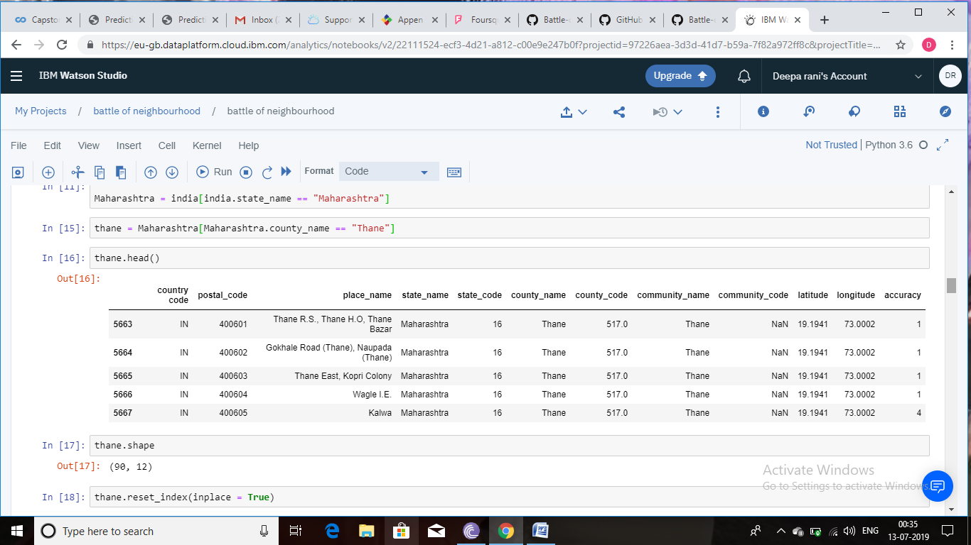

### Methodology

* By using the Forsquare API i extracted the common venues of thane and then plotted the map of thane using the folium library. The blue dots in the map below are showing the venues of the thane.

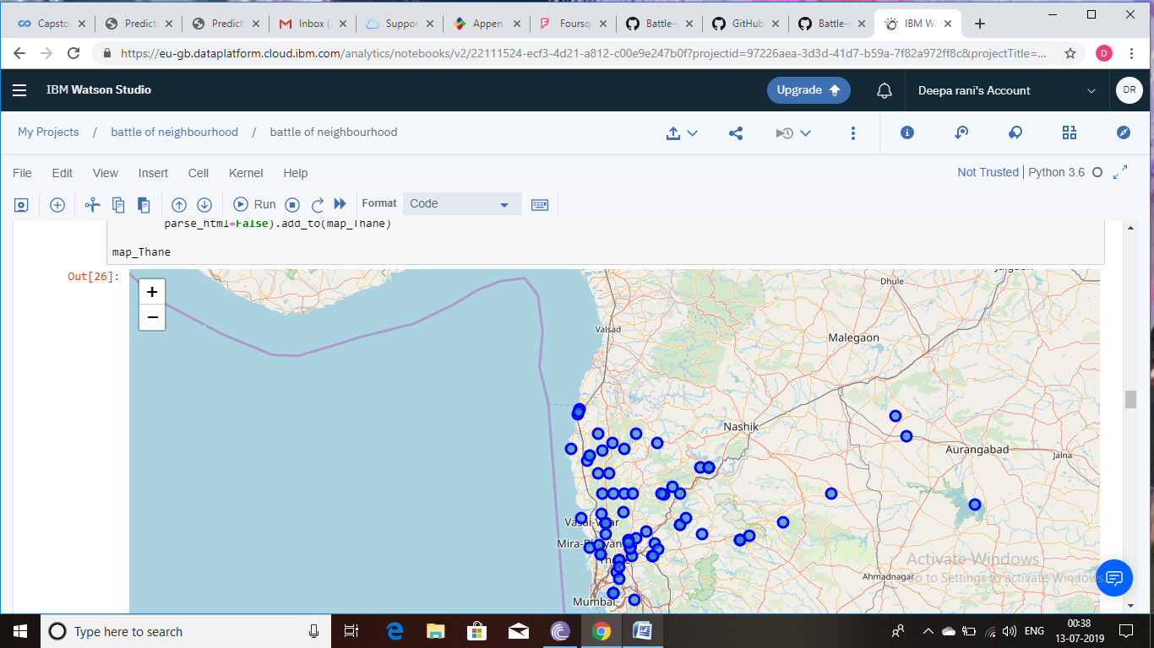

* By analyzing the map i extracted that kalyan area of thane has most numbers of spots.

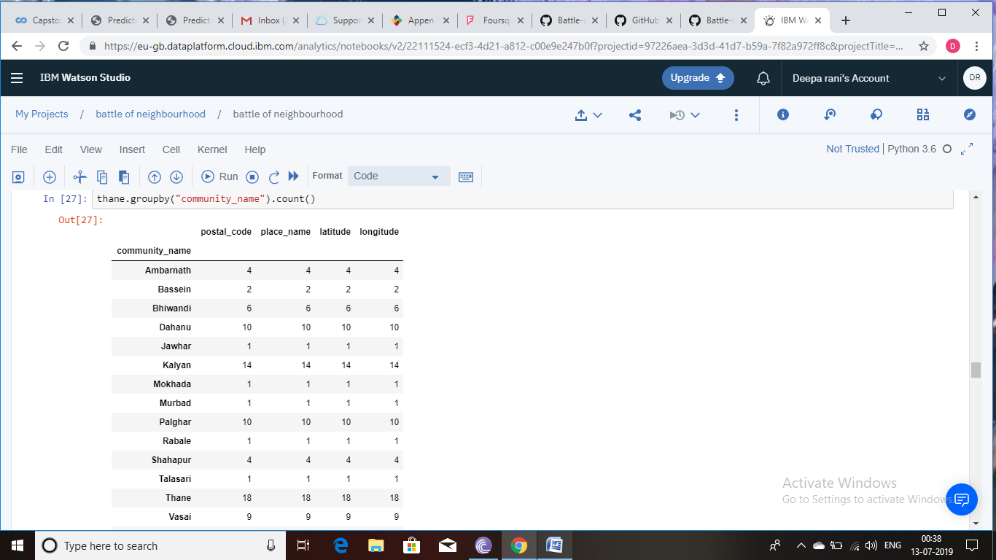

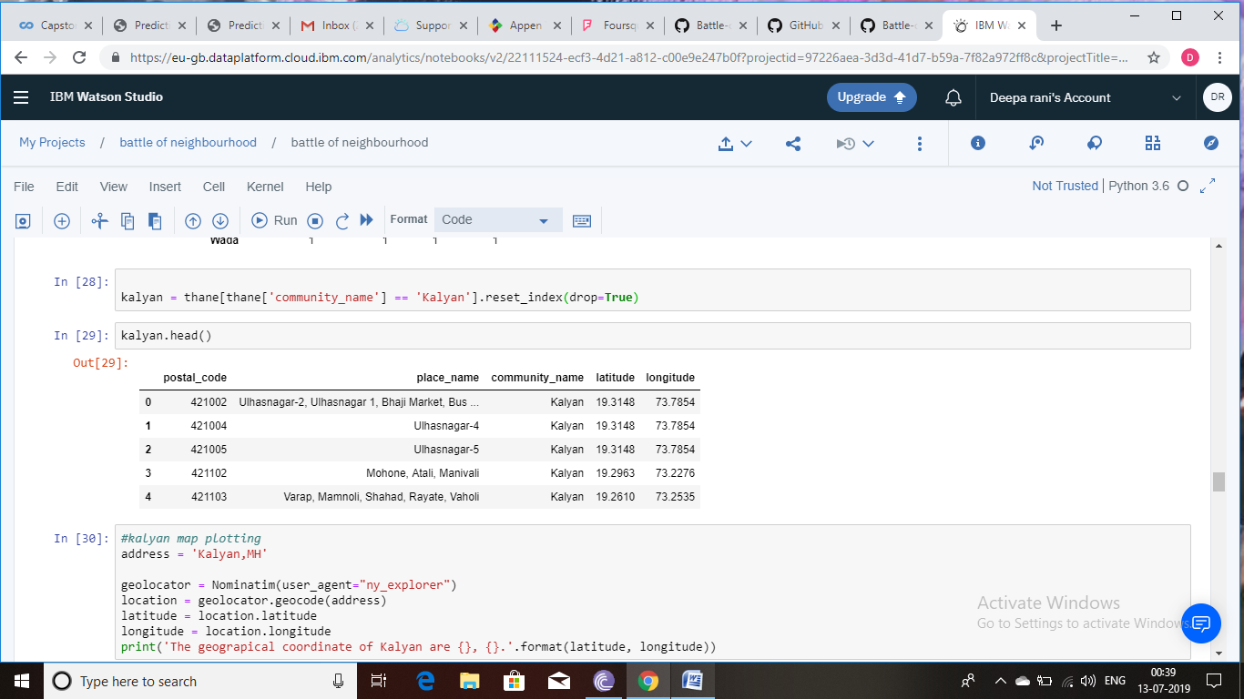

So, I have extracted the details of all of the spots in kalyan by using the API. I have explored the kalyan area in deep further.

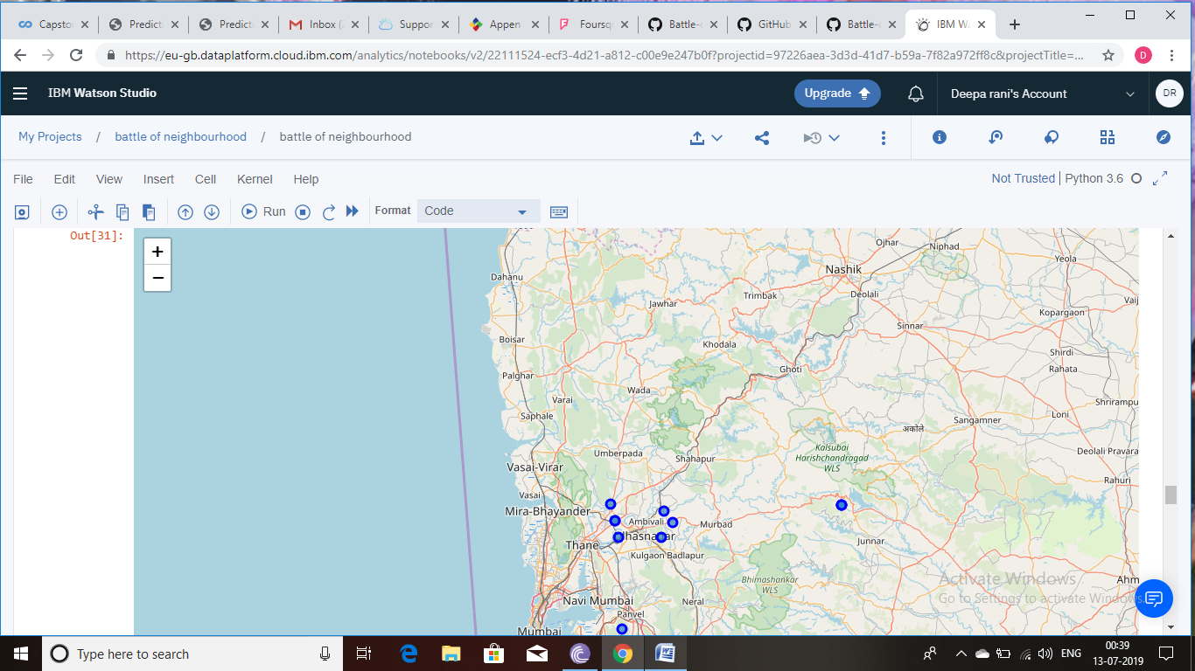

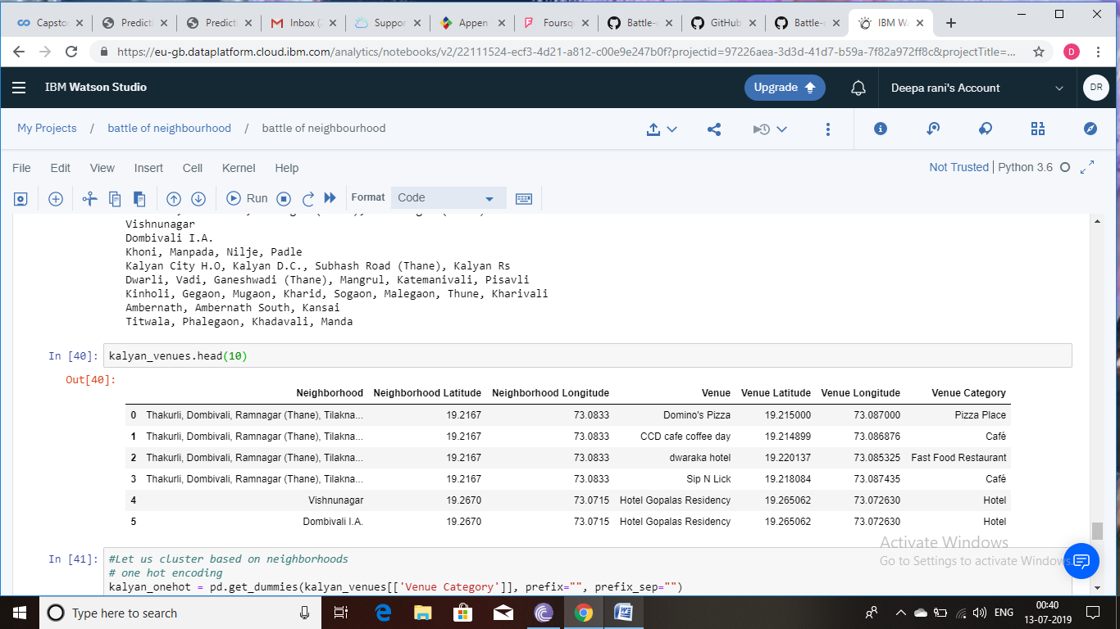

### Results

* I have extracted the venues of the thane and then categorised them based on the similarity.

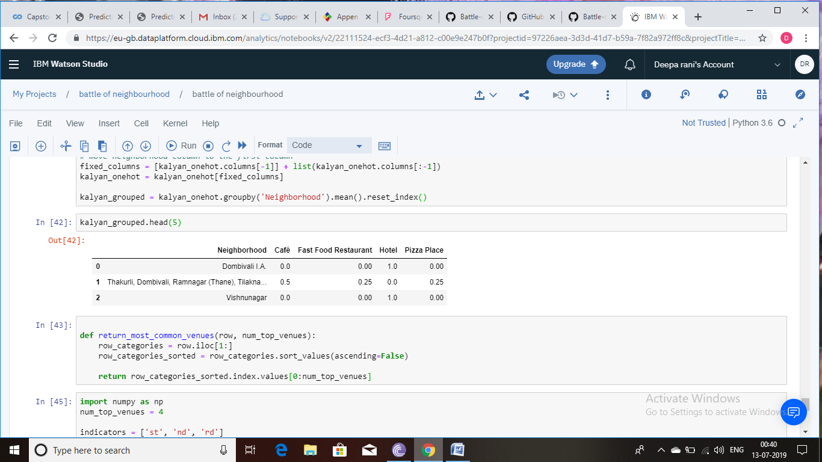

* I have used unsupervised learning **K-means algorithm** to cluster the neighbourhoods. K-Means algorithm is one of the most common cluster methods of unsupervised learning.

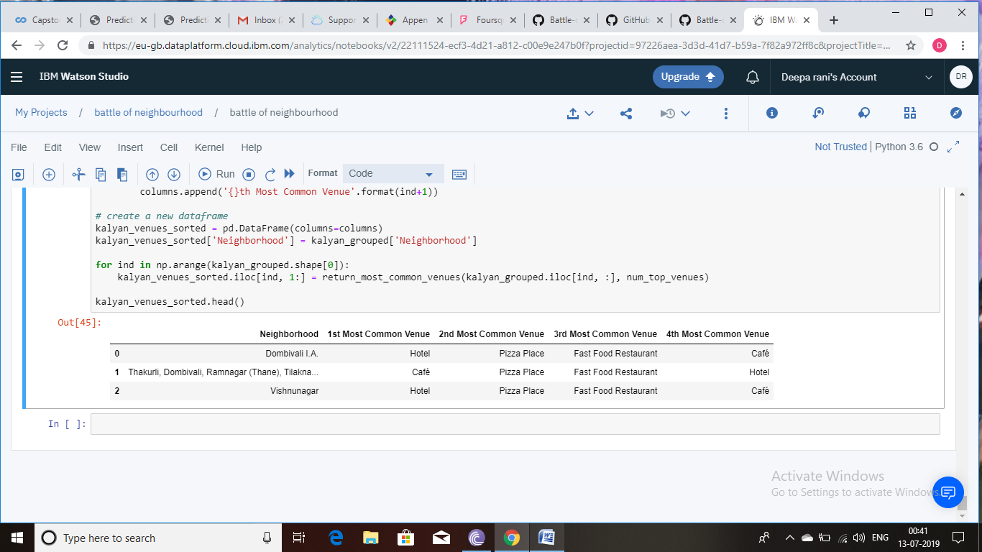

### Conclusion

People now can explore the city easily and can get the information of the city at one place. So that without wasting the time they can visit the place. By using the different libraries and tools i have visualize the venues and grouped them together based on the similarity.